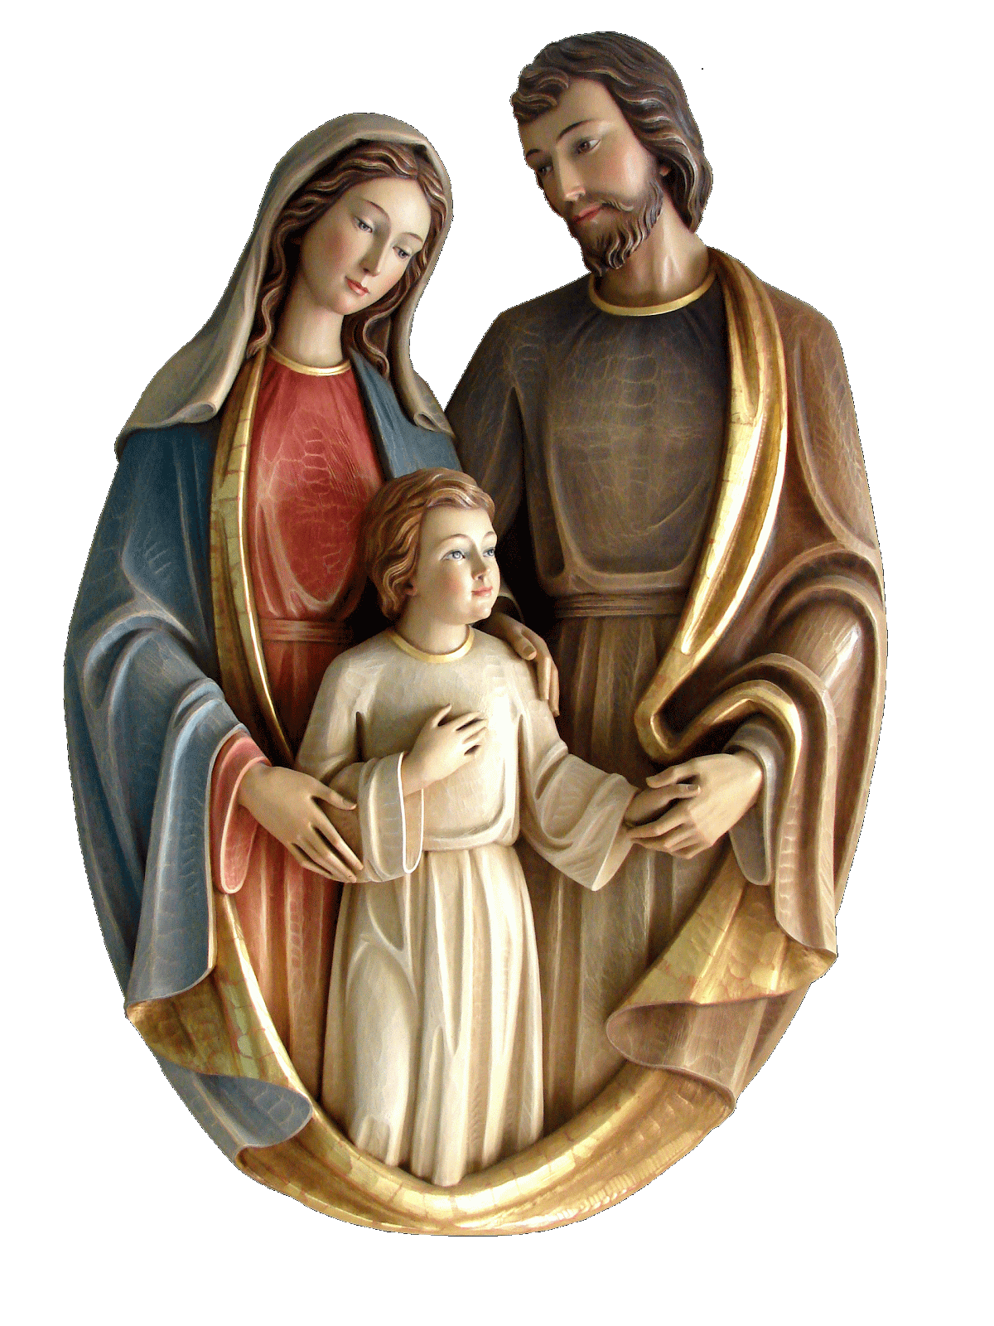**Holy Family Catholic Church** Academic Year: ________________

**Religious Education Registration** $20 fee paid: ___________________

Parent’s Name: _____________________________________________________________________________________

Address: __________________________________________________________________________________________

City: ____________________________ Zip Code: ___________ Email: _____________________________________

Home Phone: ___________________ Cell Phone: _____________________ Can We Text Message You: Yes / No

Emergency Contact Name: __________________________________________ Phone: __________________________

|  |  |  |  |  |  |  |
| --- | --- | --- | --- | --- | --- | --- |
| **Child’s Information** | **Sacraments**  **Received** | **Y/N** | **Year** | **Parish** | **Medical Conditions/Allergies**  **Other pertinent information** | **Office**  **Use** |
| Full Name: | Baptism |  |  |  |  |  |
| Reconciliation |  |  |  |  |
| Age/Birthdate: | 1st Communion |  |  |  |  |
| Grade: | Confirmation |  |  |  |  |
| Full Name: | Baptism |  |  |  |  |  |
| Reconciliation |  |  |  |  |
| Age/Birthdate: | 1st Communion |  |  |  |  |
| Grade: | Confirmation |  |  |  |  |
| Full Name: | Baptism |  |  |  |  |  |
| Reconciliation |  |  |  |  |
| Age/Birthdate: | 1st Communion |  |  |  |  |
| Grade: | Confirmation |  |  |  |  |
| Full Name: | Baptism |  |  |  |  |  |
| Reconciliation |  |  |  |  |
| Age/Birthdate: | 1st Communion |  |  |  |  |
| Grade: | Confirmation |  |  |  |  |

**\*\*\*Students preparing for Sacraments MUST present a Baptismal certificate before classes begin\*\*\***

***How can you Assist? (Please choose at least one)*** Teacher _____ Teacher’s Aide _____ Substitute Teacher __________

Snacks _____ Crafts ______ Music ______ Christmas Program ______ Other _________________________________

***Permissions:*** **My children listed above have permission to visit the Gray Cara and Aladdin Assisted Living Center in Keenesburg, Colorado throughout this academic year.**

Signed: __________________________________________________________________ Date: _____/______/______

**Iglesia Católica Sagrada Familia** Año académico: _______________________

**Registro de educación religiosa** Tarifa de $20 pagada: __________________

Nombre de los padres: _______________________________________________________________________________

Domicilio: _________________________________________________________________________________________

Cuidad: _________________ Código postal: __________ Correo electrónico: __________________________________

Teléfono de casa: ______________Teléfono móvil: _________________ ¿Podemos enviarle mensajes de texto?: Sí / No

Contacto de emergencia: _______________________________________ Número de teléfono: ____________________

|  |  |  |  |  |  |  |
| --- | --- | --- | --- | --- | --- | --- |
| **Información del niño** | **Sacramentos recibidos** | **S/N** | **Año** | **Parroquia** | **Condiciones médicas/alergias**  **Otra información pertinente** | **Uso en oficina** |
| Nombre completo: | Bautismo |  |  |  |  |  |
| Reconciliación |  |  |  |  |
| Edad/fecha de nacimiento: | 1ra Comunión |  |  |  |  |
| Grado: | Confirmación |  |  |  |  |
| Nombre completo: | Bautismo |  |  |  |  |  |
| Reconciliación |  |  |  |  |
| Edad/fecha de nacimiento: | 1ra Comunión |  |  |  |  |
| Grado: | Confirmación |  |  |  |  |
| Nombre completo: | Bautismo |  |  |  |  |  |
| Reconciliación |  |  |  |  |
| Edad/fecha de nacimiento: | 1ra Comunión |  |  |  |  |
| Grado: | Confirmación |  |  |  |  |
| Nombre completo: | Bautismo |  |  |  |  |  |
| Reconciliación |  |  |  |  |
| Edad/fecha de nacimiento: | 1ra Comunión |  |  |  |  |
| Grado: | Confirmación |  |  |  |  |

**\*\*\*** **Los estudiantes que se preparan para los Sacramentos DEBEN presentar un certificado de bautismo antes de que comiencen las clases. \*\*\***

***¿Cómo puedes ayudar? (Por favor elige al menos uno)*** Maestra(o) _____ Ayudante _____ Maestra(o) sustituta(o) _____ Bocadillos _____ Artesanía _____ Música _____ Programa de Navidad _____ Otra(o) __________________________

***Permisos:*** **Mis hijos mencionados anteriormente tienen permiso para visitar el Centro de Vida Asistida Gray Cara y Aladdin en Keenesburg, Colorado, durante este año académico.**

Firma: __________________________________________________________________ Fecha: _____/______/______