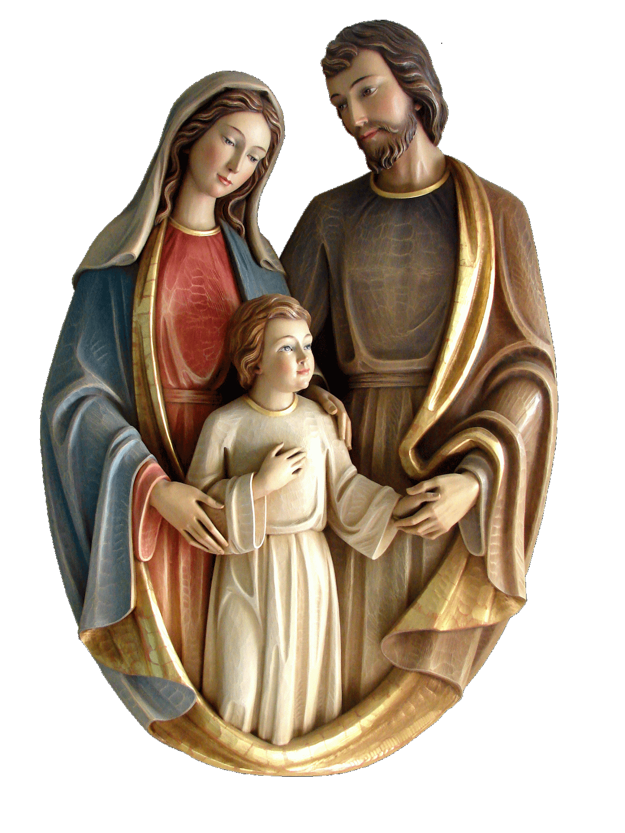 Holy Family Catholic Church

***SPONSOR’S AFFADAVIT***

***THE SACRAMENT OF CONFIRMATION***

I, ___________________________________________________________will be the Sponsor of (Sponsor’s printed name)

_____________________________________________ at Holy Family Catholic Church in Keenesburg, CO.

(Candidate’s printed name)

My relationship with the candidate is __________________________________________________ and

I’ve known the candidate for about _______________________________________________________.

According to the regulations as a Catholic Sponsor, I must meet the following qualifications:

* **I am a practicing Catholic who has received the following Sacraments:**

Baptism Yes / No

First Communion Yes / No

Confirmation Yes / No

Are you constantly receiving the Sacrament of Penance? Yes / No

I am Single/Married.

You must provide a copy of your Catholic Confirmation certificate; and if married, your Catholic Marriage certificate. Certificate must be signed and sealed by the church where the sacrament was received.

* **As a practicing Catholic, I am receiving Communion at the Mass.**
* **I am at least 17 years of age or older.**
* **I am neither the mother nor father of the candidate.**
* **I have every intention of fulfilling my role as Sponsor by assisting the candidate in growing as a Catholic Christian.**

__________________________________________________________________________________________________

Sponsor Address City, State, Zip Code Phone Number

I swear that all the statements above are true. I also hereby assure that I am committed to help this candidate to grow as a practicing Roman Catholic.

Sponsor Signature ______________________________________________ Date ______________________

**STATEMENT OF PARISH PRIEST**

This is to certify that ____________________________________________________ to the best of my knowledge is:

(Name of Sponsor)

* A registered member of this parish.
* A regular participant at Sunday Mass.
* A Catholic in good standing according to the laws of the Church.

Priest’s Signature: ________________________________________________ Date _______________________

*(Church seal)*

Church: ________________________________________________________

Address: ________________________________________________________